**Front - End Assignment**

**Part 1 : Web Designing**

**Module – 6 : Bootstrap Basic & Advanced**

1. **What are the advantage of Bootstrap ?**

* Bootstrap is a popular framework for building responsive and visually appealing websites.

1. **Easy to use** : Bootstrap provides a collection of pre-built components, such as buttons, forms, navigation bars, and grids, which can be easily customized and used in your website without the need for extensive coding knowledge.
2. **Responsive design :** Bootstrap is designed to create responsive websites that automatically adapt to different screen sizes and devices. This means your website will look great on deskops, tablets, and smartphones without requiring seprate code for each device.
3. **Time Saving :** Since Bootstrap offers ready-made components and templates, it significantly reduces development time. Developers can simply plug in the Bootstrap code and customize it according to their needs, saving hours of coding and desing work.
4. **Cross-browser compatibility :**  bootstrap is developed and tested to work efficiently various web browsers, including Chrome, Firefox, Safari and and Internet Explorer. This ensures that your website will have a consistent experience regardless of the browser being used.
5. **Mobile First Approach :** Bootstrap follows a mobile-first approach, meaning it prioritiez for mobile devices first and then scaling up to larger screens. This helps create websites that are optimized for mobile users, who make up a significant portion of internet traffic.
6. **What is a Bootstrap Container, and how does it work ?**

* In Bootstrap, a container is a fundamental layout element used to create a structured and responsive grid system. It helps to organize and align the content of a webpage.
* **Container :** This is a fixed-width container that has a responsive behavior. It means that the container width adjusts according to the screen size. On larger screens, the content is centered within a specific maximum width, creating a neat and organized layout. On smaller screens, the container’s width decreaces to fit the screen size, ensuring the content remains readable and well-structured.

Example in Code :

**<div class=”container”>**

**<!-- Content was here. -->**

**</div>**

* **Container-fluid :** This type of container spans the entire width of the viewport, fluidly adapting to different screen sizes. It stretches from edge, without any fixed width limitation. It allows your occupy the full available width, making it ideal for full-width sections or hero banners.

Example in Code :

**<div class=”container-fluid”>**

**<!-- Content was here. -->**

**</div>**

1. **What are the default Bootstrap text settings ?**

* In Bootstrap, there are several default text settings that you can apply to your website content. These settings help you style and format text in a consistent and visually appealing way.
* Headings : Bootstrap provides predefined classes for headings from <h1> to <h6>. These classes apply consistent font sizes and styles to your headings, making them visually distinct and easy to read.
* **Paragraphs** :Bootstrap applies a default font size and line height to paragraphs (<p> tags) to ensure readability. The default font family is usually set to the browser’s default, but you can easily override it if desired.
* **Text alignment :** Bootstrap offers classes to align text horizontally. ‘.text-left’, ‘.text-center’, ‘.text-right’ and ‘.text-justify’ classes can be applied to any element to align the text to the left, center, right and justify it respectively.’
* **Font weight and style :** Bootstrap provides classes to adjust the font weight and style of text. The classes ‘font-weight-bold’ and ‘.font-weight-normal’ can be used to make text bold or reset it to the normal fot=nt weight. Addiionally, you can use ‘.font-italic’ to apply an italic style to the text.
* **Text color :**  Bootstrap includes text colors classes that allow you to change the color of text. For example, ‘.text-primary’ sets the text color to the primary color defined in Bootstrap’s color palette. Similarly, these are classes like ‘.text-success’, ‘.text-danger’, ‘.text-info’, and more for different color options.
* **Text transformation :** You can transform the case of text using Bootstrap classes. For example, ‘.text-lowercase’ converts text to lowercase, ‘.text-uppercase’ converts it to uppercase and ‘.text-capitalize’ capitalizes the first letter of each word.

Examples :

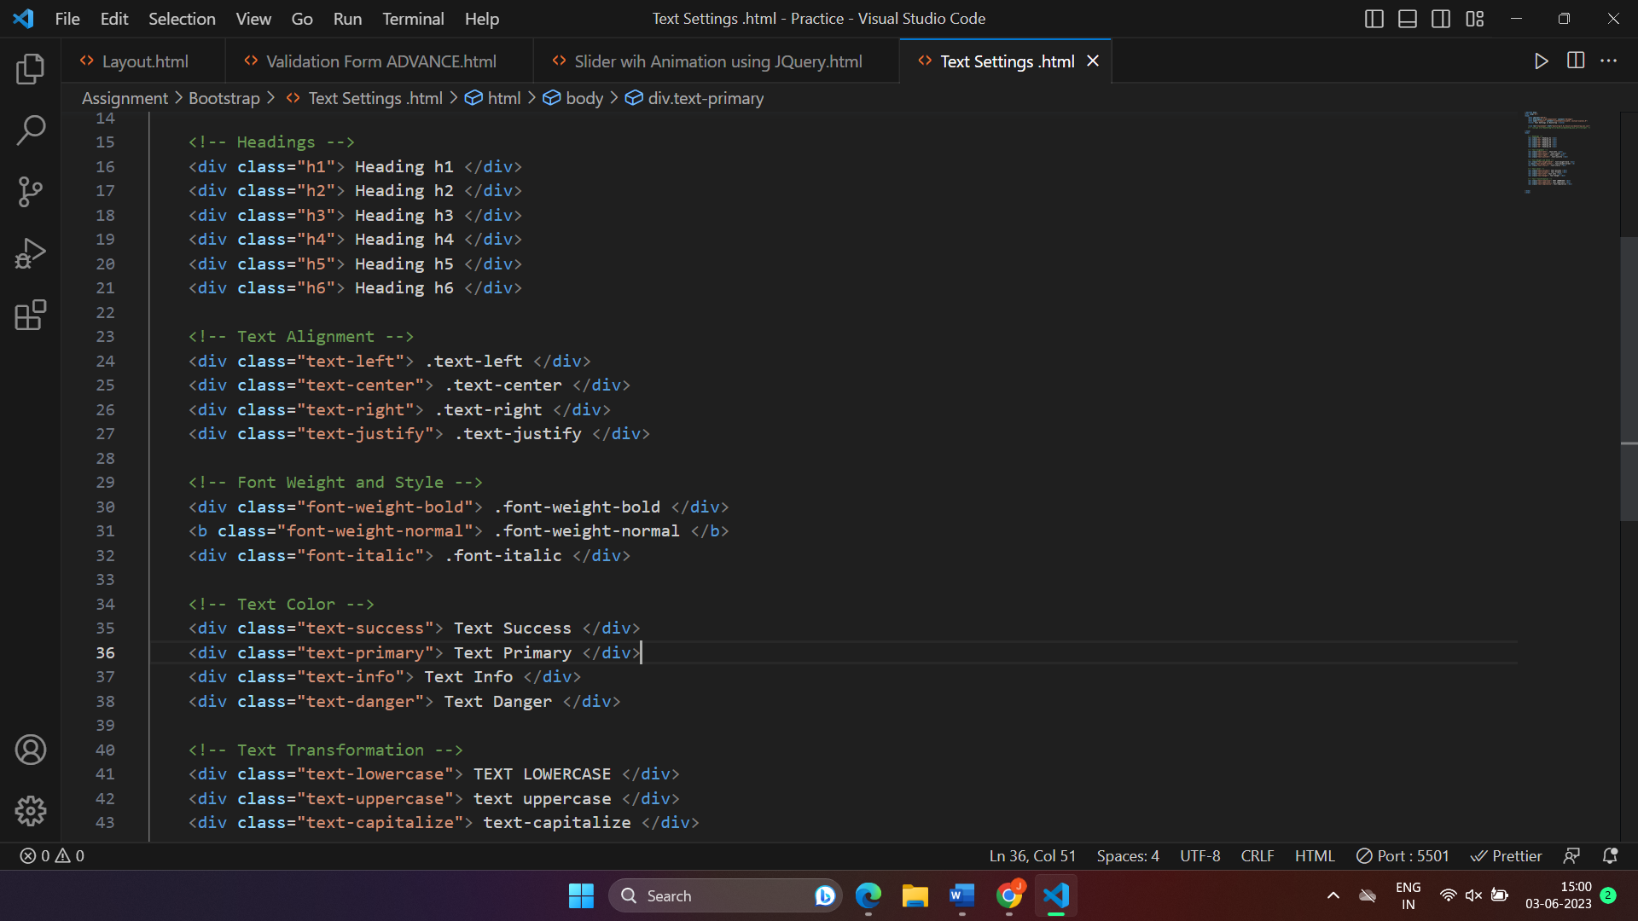

1. **What do you know about the Bootstrap Grid System ?**

* The bootstrap Grid System is a powerful feature that allows you to create responsive and flexible layouts for your website. It provides a structured grid of rows and columns, making it easier to organize and align your content.
* **Grid Structure** :
* The grid is divided into 12 euual columns by default, represented as ‘ .col- ’.
* We will combine multiple columns to create a row. For example. If you use two columns with ‘ .col-6 ’, they will each occupy half of the row.
* **Responsive Behaviour** :
* Bootstrap’s grid system is responsive, meaning it automatically adapts to different screen sizes.
* We will define different column sizes for different screen widths using predefined breakpoints : extra small (xs), small (sm), medium (md), large (lg) and extra large (xl).
* For example, you can use ‘ .col-lg-6 ’ to specify that a column should occupy half the width of the row on large screens, but have a different size on smaller screens.
* **Nesting Columns** :
* We will create more complex layouts by nesting columns within columns.
* This allows you to divide a column into smaller sections, each with its own set of columns.
* For example, you can have arow with two columns and within one of those columns, we can have another row three columns.
* **Offset and Alignment** :
* Bootstrap provides classes to offset and align columns within a row.
* The ‘ .offset-* ’ classes allow you to create empty spaces before a column, pushing it to the right.
* The alignment classes, such as ‘ .justify-content-start ’ , ‘ .justify-content-center ’ and ‘ .justify-content-end ’ , help you align columns horizontally within a row.

1. **What is the difference between Bootstrap 4 and Bootstrap 5 ?**



|  |  |  |
| --- | --- | --- |
| **Basics of** | **Bootstrap 4** | **Boostrap 5** |
| **Grid System** | It has 5 tier (xs, sm, md, lg, xl) | It has 6 tier (xs, sm, md, lg, xl, xxl) |
| **Color** | It has limitred colors. | Extra colors added with the looks, A card improved color palette. There are various shades available to choose. |
| **JQuery** | It has jquery and all related plugins. | Jquery is removed and switched to vanilla JS with some working plugins. |
| **Internet Explorer** | Bootstrap 4 supports both IE 10 and 11. | Bootstrap 5 doesn’t support IE 10 andd 11. |
| **Form Elements** | Radio buttons, checkboxes have different look in different OS and Browsers. The form uses whatever default browsers provide. | The look of form elements will not change, on different OS or Browser. The forms can be customized and form controls can be added, they would not depend on browser. |
| **Bootstrap Icons** | Bootstrap 4 doesn’t have its own SVG icons, we have to use font-awesome for icons. | Bootstrap 5 have its own SVG icons. |
| **Navbar** | We have inline-block property and we will get white dropdown as defaults for dropdown-menu-dark class. | Inline-block property is removed and we will get black dropdown as default for dropdown-menu-dark class. |

1. **What is a Button Group, and what is the class for a basic Button Group ?**

* A Button Group in Bootstrap is a way to group multiple buttons together, creating a visually cohesive and functional unit. It allows you to apply styles and behaviors to the group as a whole. Here's an easy way to understand a Button Group in Bootstrap:

Think of a Button Group as a collection of buttons that are related or meant to be used together. By grouping them, you can create a consistent look and apply common functionality to the buttons within the group. For example, you might have a group of buttons for selecting different options, or for performing actions that are related.

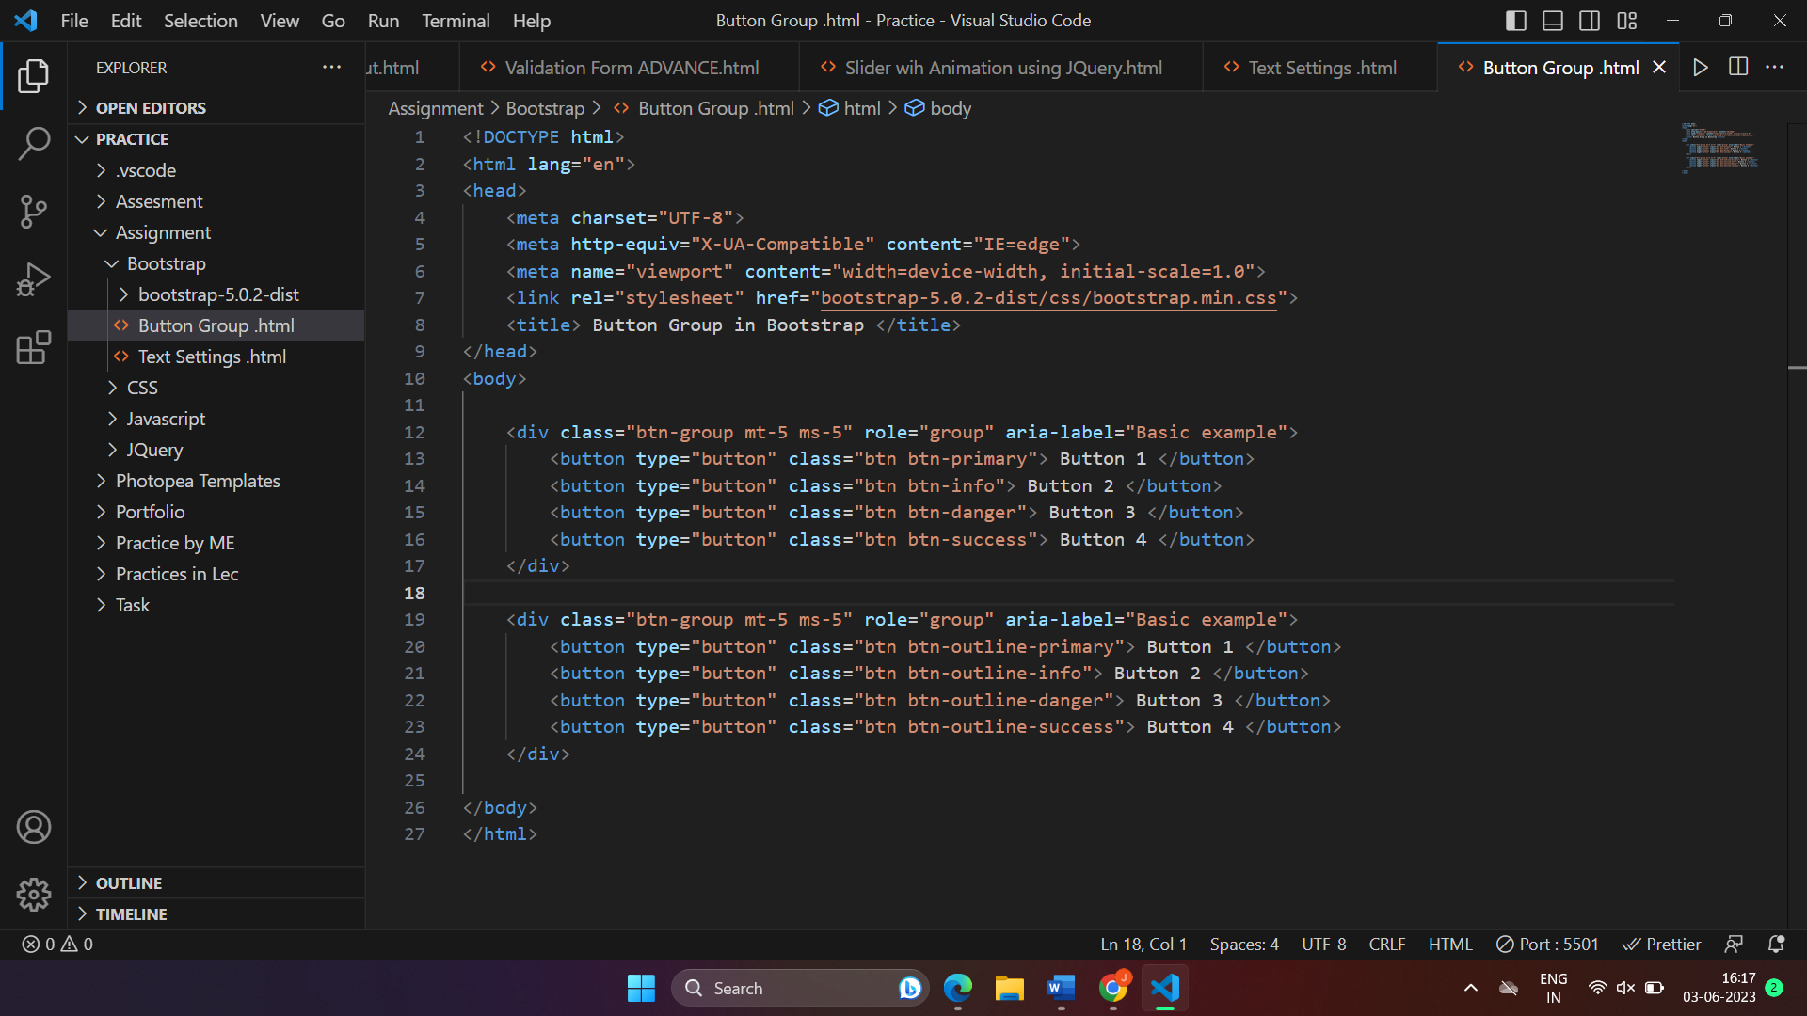

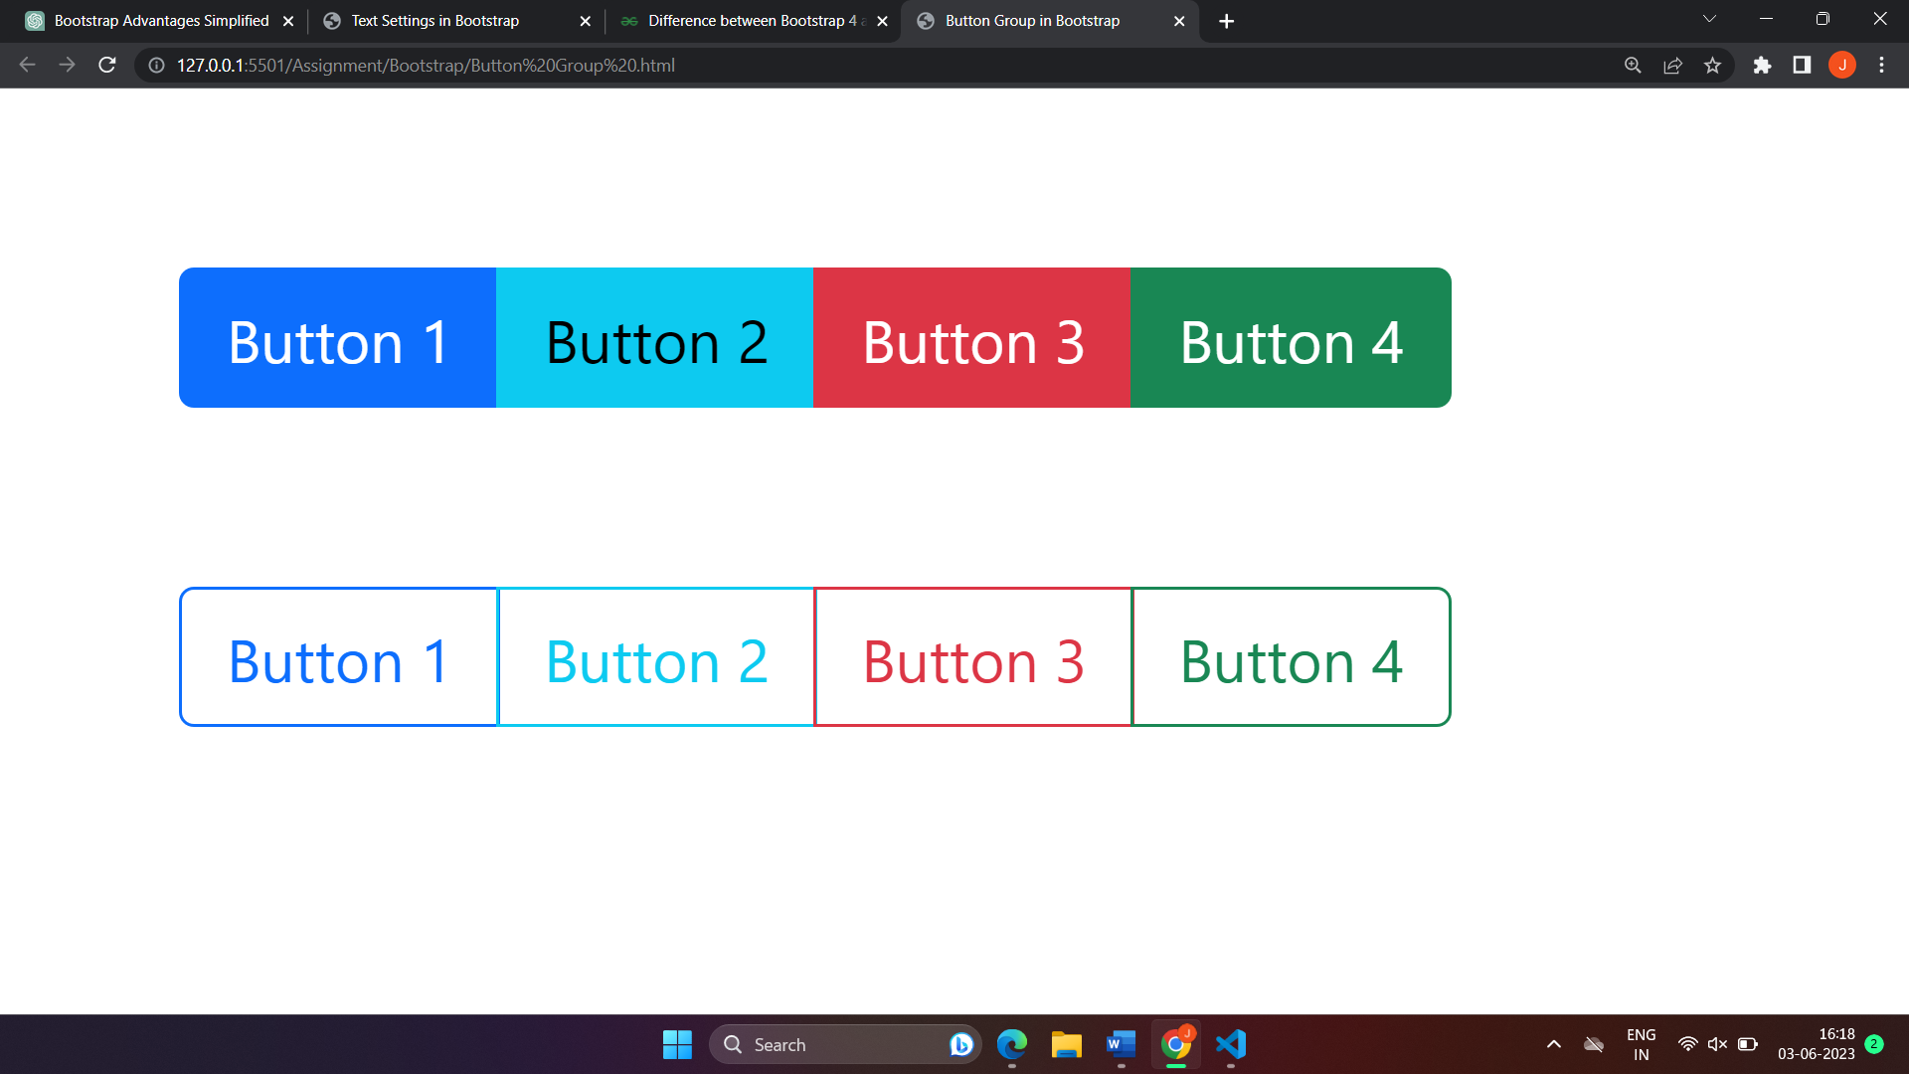

1. **How can you use Bootstrap to make thumbnails ?**

* In Bootstrap, you can use the "Thumbnail" component to create visually appealing image thumbnails. Thumbnails are small images that serve as previews and can be clicked to view a larger version of the image or to navigate to another page. Here's an easy way to understand how to create thumbnails using Bootstrap :

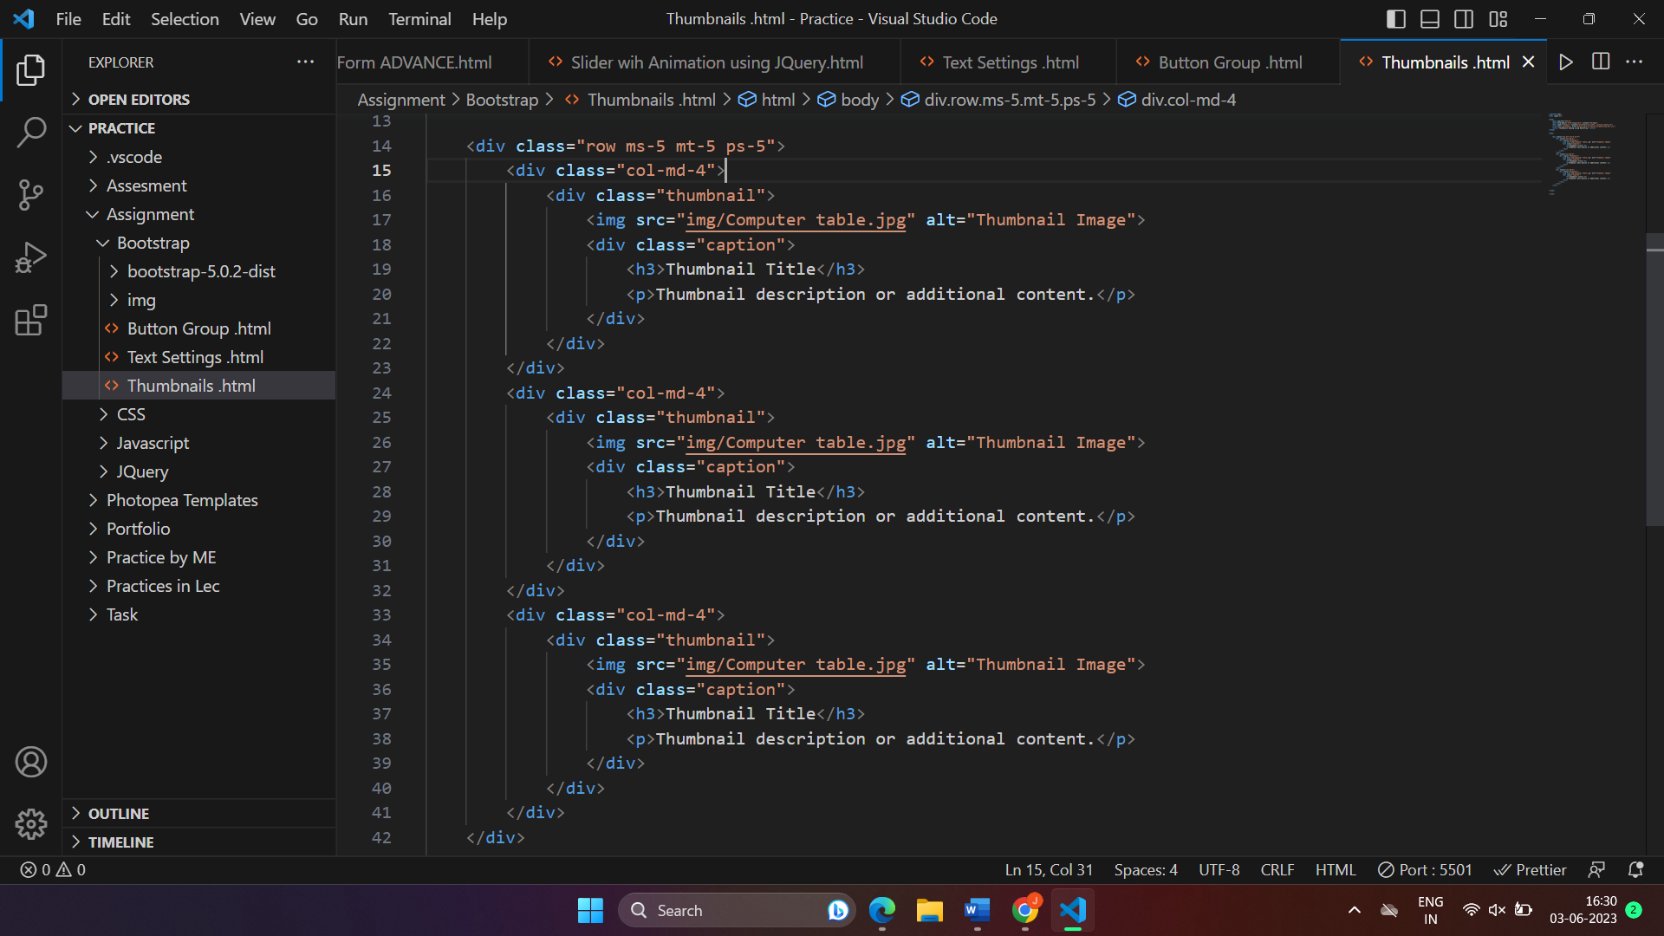

1. **In Bootstrap 4, what is flexbox ?**

* In Bootstrap 4, Flexbox is a CSS layout model that helps in creating flexible and responsive designs. It provides a set of CSS properties and values that allow you to easily arrange and align elements within a container.

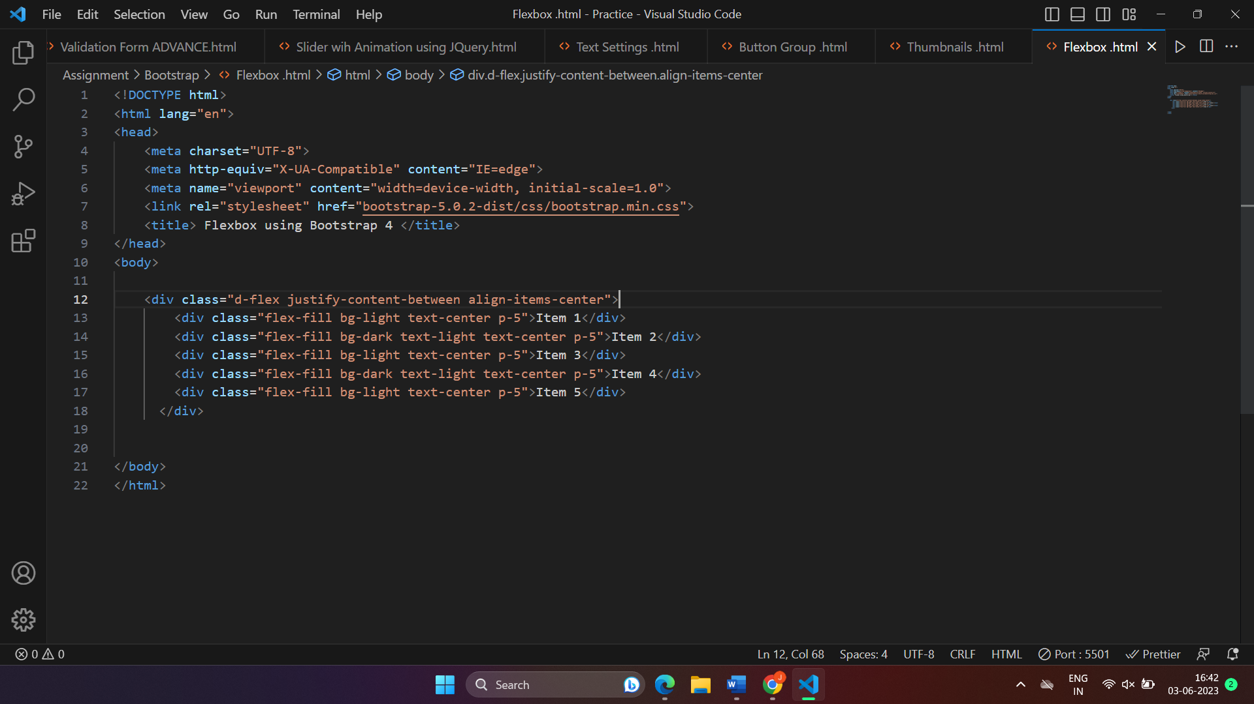

1. **How can one create an alert in Bootstrap ?**

* Creating an alert in Bootstrap is simple and can be achieved using the predefined alert classes.

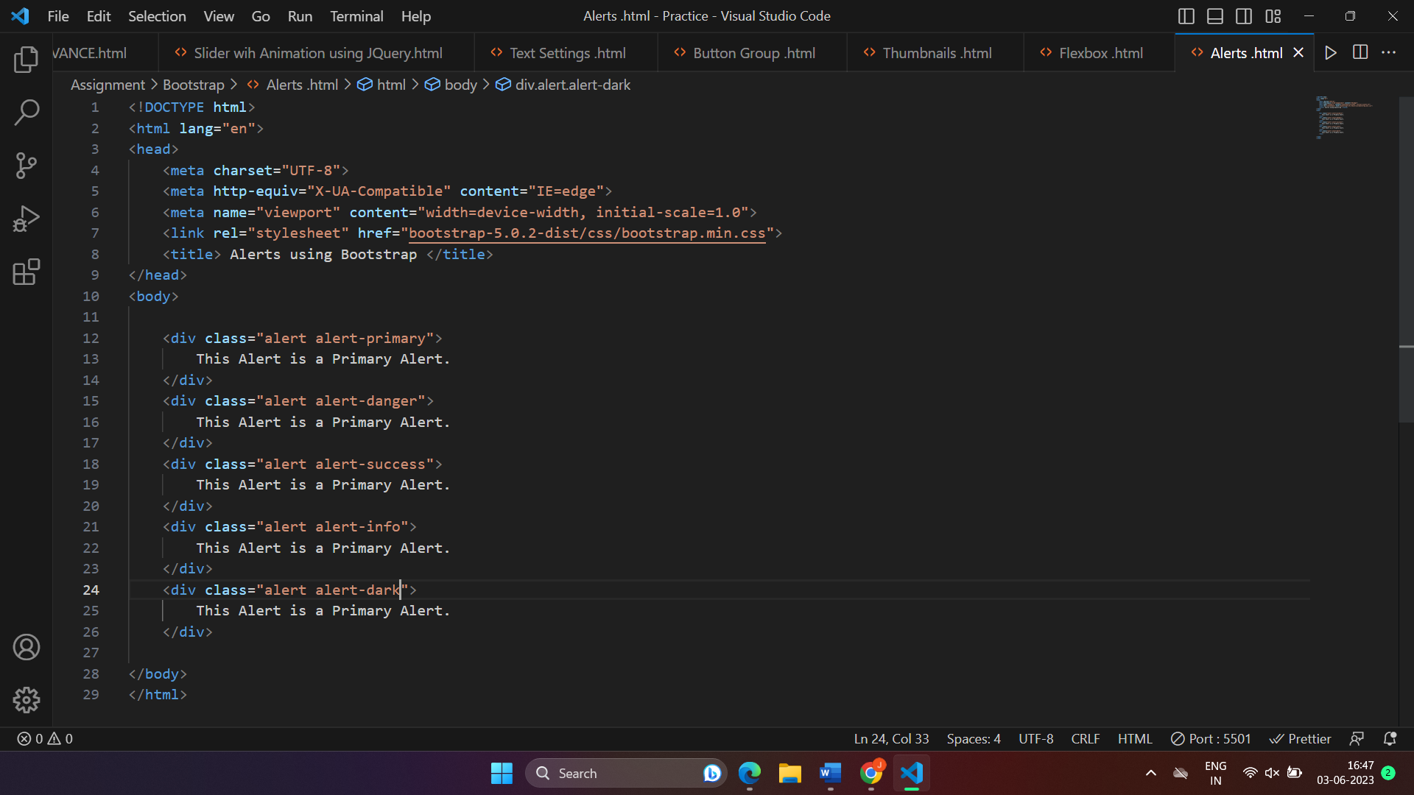

1. **What is bootstrap card and how would you create one ?**

* In Bootstrap, a Card is a versatile and flexible content container that allows you to present information or elements in a structured and visually appealing way. It provides a clean and organized layout for displaying various types of content.

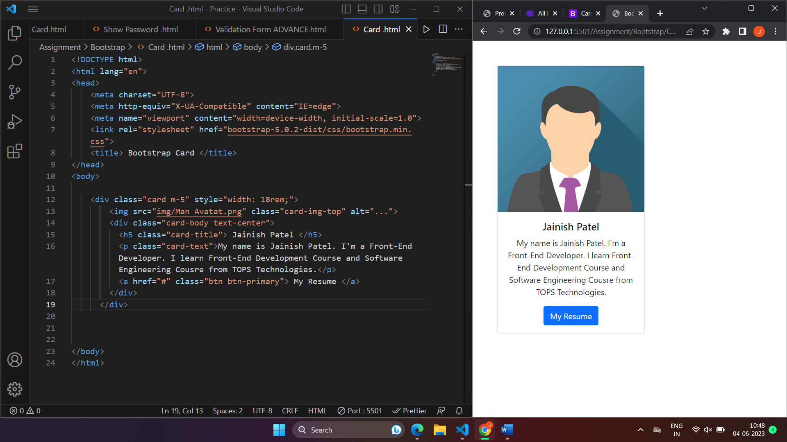

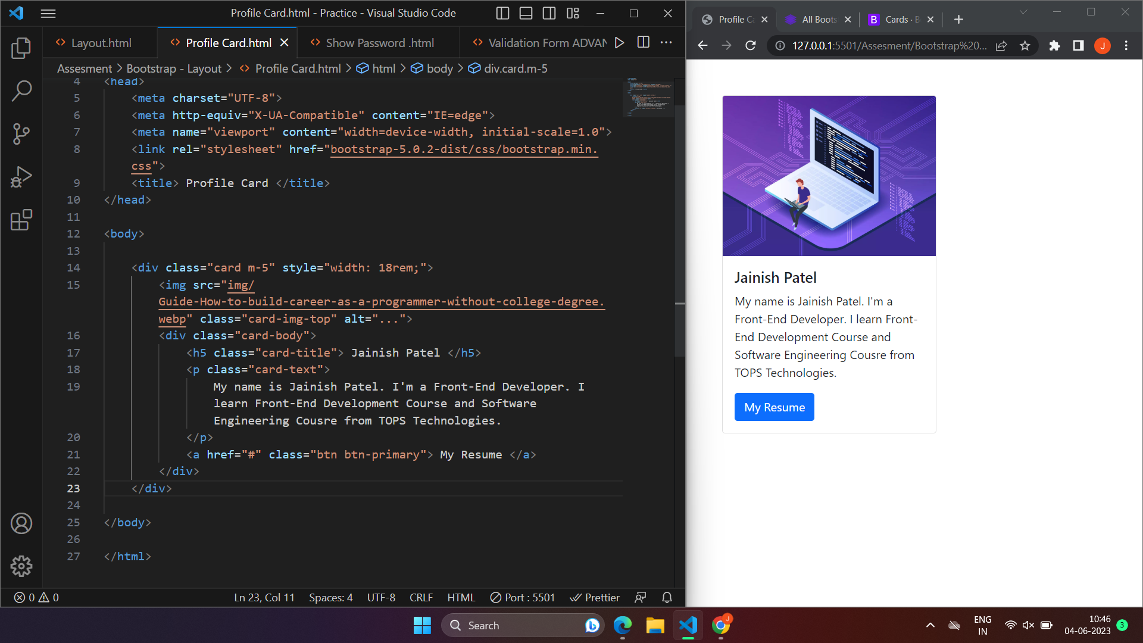

Bootstrap Assignment **Layout :**



Bootstrap Assignment **Card or Profile Card :**

 

Bootstrap Assignment **Alerts :**



Bootstrap Assignment **Button-Group :**



Bootstrap Assignment **Flexbox :**



Bootstrap Assignment **Text Settings :**



Bootstrap Assignment **Thumbnails :**

